Project Delay Prediction – Summary Document
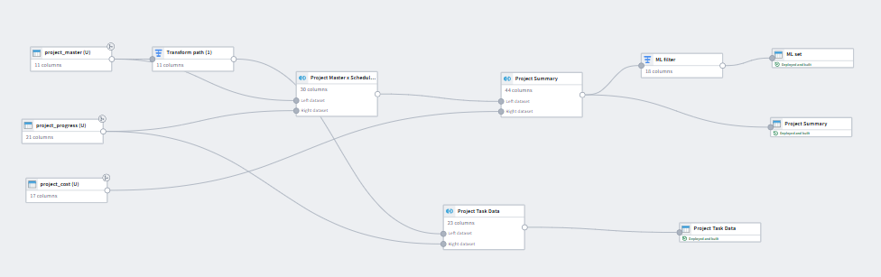
1. What the model does
The model predicts how many days each task is likely to be delayed.
Based on these task-level predictions, it then estimates the overall delay for each project.

2. How task delay is predicted
I trained a machine-learning model (Random Forest Regressor) using past completed tasks.
The model learns patterns between:
- task characteristics,
- external factors, and
- how long the task actually got delayed.
It then uses these patterns to predict delays for tasks that are In Progress or Not Started.

3. What information is used to train the model
Here are the key inputs the model uses:
Basic Identifiers
(Used only for tracking, not for prediction)
- project_id
- task_id
- task_name
- task_status
Target to be predicted
- Task_task_delay_days (how many days the task is delayed)
Main Features Influencing Delay
- Task_planned_duration_days – Longer tasks have higher risk of delay
- Task_percent_complete – Shows progress
- Task_priority – Critical tasks usually face more pressure
- Task_labor_hours – Higher effort tasks
- Task_material_shortage_flag – Delays from material unavailability
- Task_supplier_lead_days – Waiting time for suppliers
- Task_equipment_delay_days – Equipment-related delays
- Task_weather_delay_days – Weather-related delays
- Task_total_external_delay_days – Combined external delays
- cost_variance_percent – Over-budget tasks often face issues
- budget_allocated – Bigger tasks may carry more risk
- state – Regional conditions (weather, regulations, etc.)
- budget_usd – Project scale context

4. How project delay is calculated
Once task delays are predicted:
- Each contractor works on multiple tasks.
- I add up the delays for all tasks handled by each contractor.
- The contractor with the highest total delay determines the final project delay, because the project can only finish once all contractors are done.
- Since projects run one after another, the delay of one project directly puts the next one on hold.
  - This results in Days_On_Hold and Delay_After_Start in the final output.
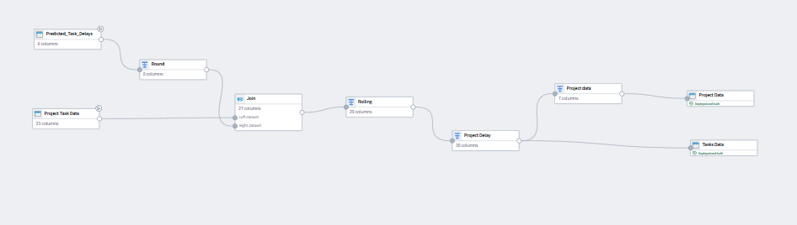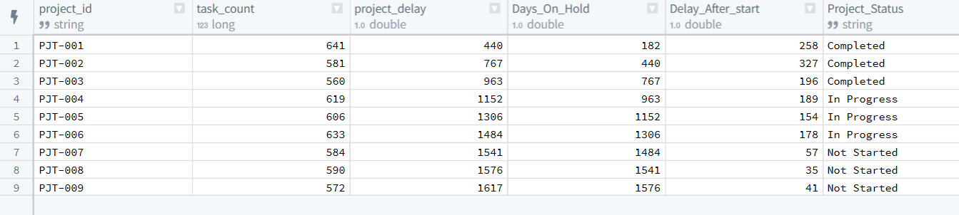
5. What the final Project delay table shows
For each project, you will see:
- number of tasks
- predicted delay
- days it stays on hold because of the previous project
- final adjusted delay
- current status (Completed / In Progress / Not Started)

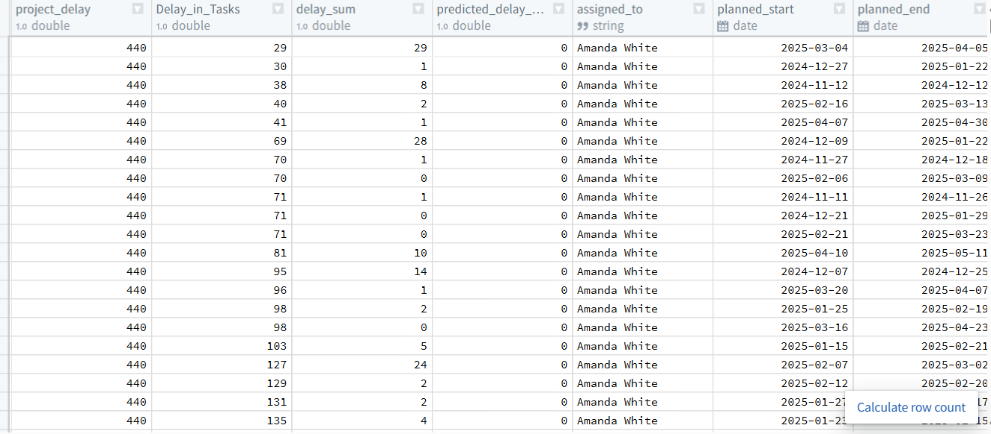

6. What the Final Tasks Output Shows
The final table shared includes:
- Total number of tasks in the project
- Predicted delay based on contractors’ combined delays
- How long the project must wait because the previous project is delayed
- Final delay after adjusting for hold time
- Current status (Completed / In Progress / Not Started)
This gives a full picture of both task-level risks and overall project timing impact.

